  
Software Engineering Department

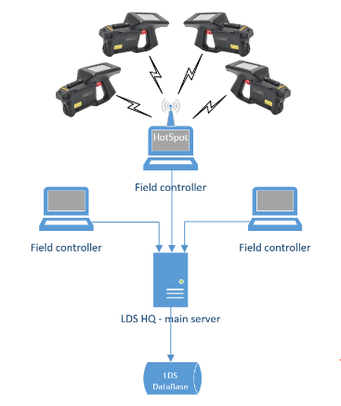**COMMAND AND CONTROL SYSTEM FOR  
HAZARDOUS SUBSTANCES**

**VISUALIZE, CONTROL, ANALYZE AND SHARE DATA IN REAL TIME**

Our system provides a visual control dashboard which displaying data that being collected in Real Time. The data is being processed using dynamic algorithms which trigger alerts for various kinds of events i.e. materials combination

|  |  |  |  |  |
| --- | --- | --- | --- | --- |
| **Arye Kogan** |  | **aryekogan@gmail.com** |  | **Academic Supervisor: Dr. Radel Ben-Av** |
| **Tomer Achdut** |  | **tomera90@gmail.com** |  | **Industrial Supervisor: Mr. Ran Avni** |
| July 2017 Tamuz 5777 | | | | |

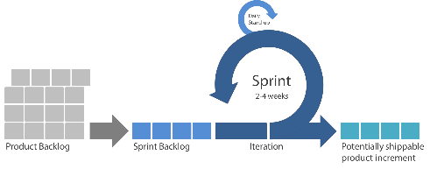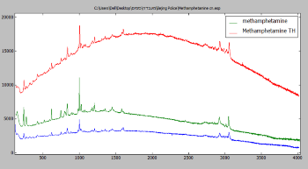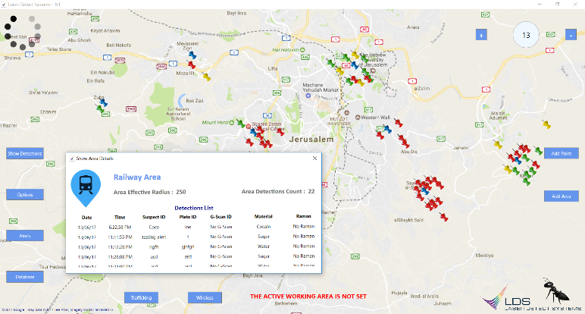

**PROJECT MANAGEMENT**

Using Agile – SCRUM methodology. Fixable iterative planning method while continuously integrating the customer’s requirements in each iteration.



**DATA SYNCHRONIZATION**

* Establishing a main Server (HQ).
* Establishing a centralized Data Center.
* Implementing a secured   
  Real Time synchronization   
  algorithm.



**ADVANCED SECURITY**

* Using HTTPS for encrypted data transfer (over SSL).
* Hashed passwords.
* Limited user session.

**5**

**3**

**4**

**4**

**FROM SINGLE PRODUCT, TO INTEGRATED SYSTEM**

**WIRELESS CONNECTIVITY COMMUNICATION**

* Integrating WiFi ingredient into the gun   
  in order to improve data transfer method.
* Developing a tiny server into the gun’s App.
* Automatic wireless data sharing between the   
  guns and the Command and Control system.

**2**

**1**

**INITIAL STATE**

A laser gun which able to detect dangerous substances using a unique Raman signature.  
**Manual** data analysis and maintenance.

**Abstract Factory**

**SOFTWARE ENGINEERING AS AN INTEGRAL PART OF THE PROJECT**

Software design – our architecture followed  
by all **SOLID** principles, providing a modular,   
distributed, expandable and bug free system while   
preserving user friendly maintenance capabilities.

**MVC**

**Proxy**

**Observer**

**Singleton**

**Command**

**Visitor**